Helm Chart
It’s a package of files that will be used to deploy applications to Kubernetes

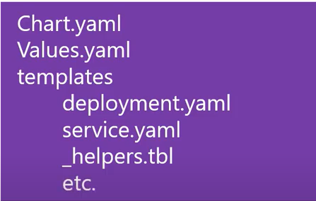

Helm is a tool that uses package management to enable creating , installing , and managing applications inside of Kubernetes much easier , configurable and repeatable .

Why to use Helm?

- Find prepackaged software (charts) to install and use
- Easily create and host your own packages
- Install packages into any Kubernetes cluster
- Query the cluster to see what packages are installed and running
- Update , delete , rollback , or view the history of installed packages
- Helm makes it easy to run applications inside Kubernetes

How does Helm work?

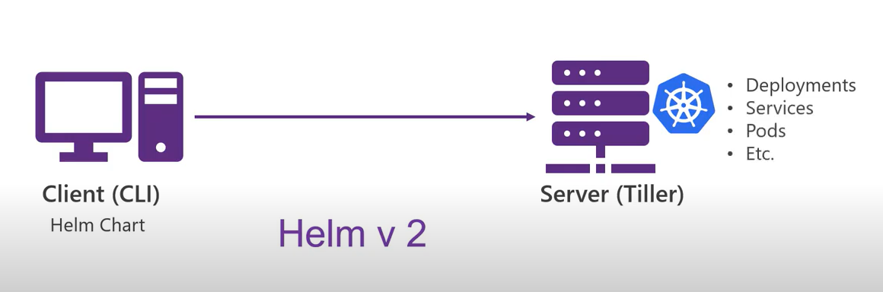

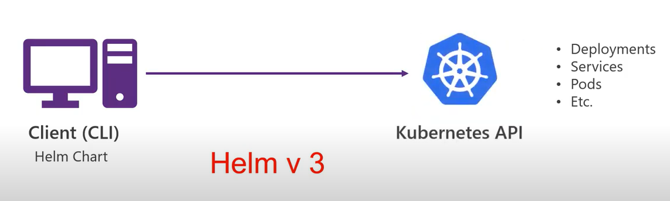

Examples of Helm commands

- Create
- Install
- Repo add
- Search

Demo

- Install Azure CLI
- Install Chocolatey
- Install Helm Client choco install Kubernetes-helm
- Create ACR & AKS

Microsoft sample devops space Azure/dev-spaces

helm create webfrontend
helm install webfrontend webfrontend/

